**Manuals for ‘Manage Page’**

**Brief of the ‘Manage Page’ –** This is the page where we manage the content of following pages.

1. About Us
2. Advance Courses
3. certifications
4. contact us
5. Corporate Profile
6. DNB Program
7. Frequently Asked Questions
8. Fellowship
9. from the chairman’s desk
10. health check up
11. health check-up comprehensive
12. Hospital Facilities
13. international patients
14. Intern-ship
15. management
16. Nursing Program
17. privacy-policy
18. quality-corner
19. research-paper
20. scope of services
21. technological milestone
22. vision and mission

**1. How to manage content -.**

Steps:

1. Login to the site and go to ‘Masters’ tab and click on ‘Manage page’.
2. Now select the page type , which we want to update.
3. Update the page content fields.
4. Click on ‘Save’ button.
5. The update content will display on respective page.

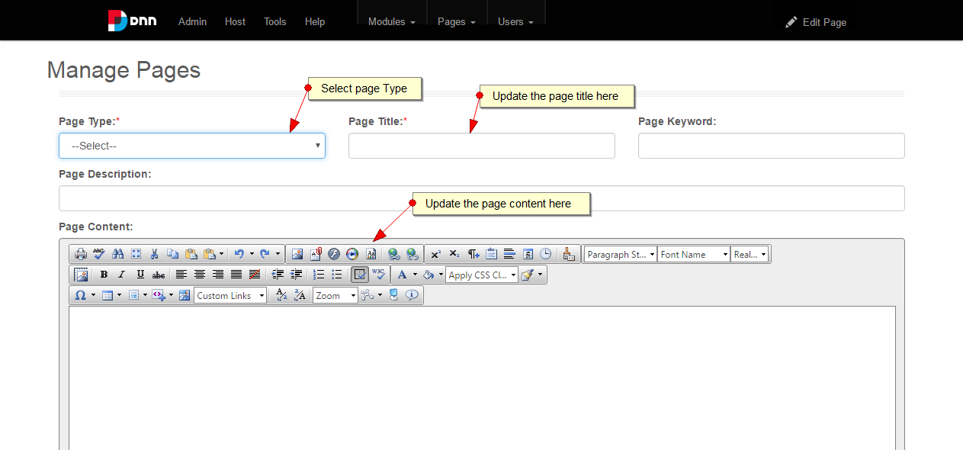

2.

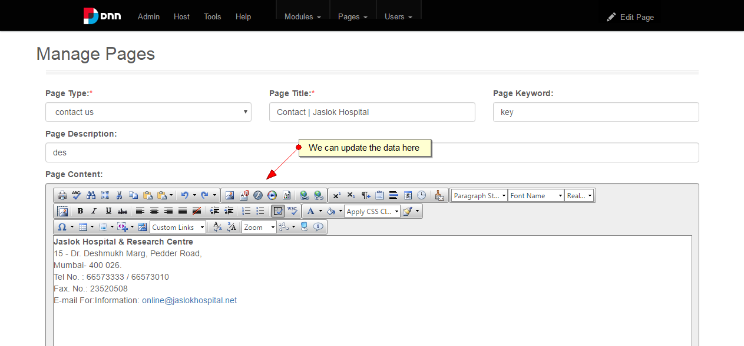

3.

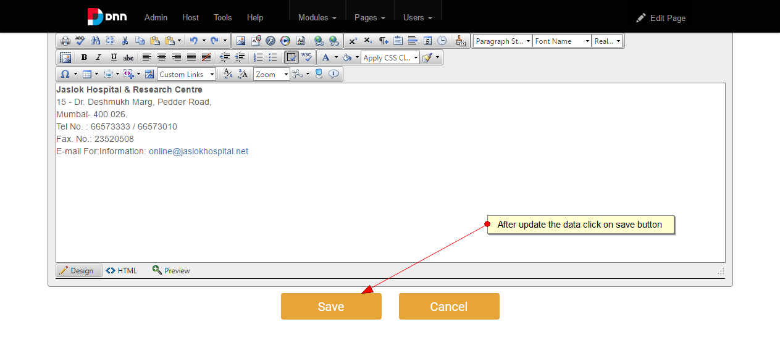

4.

